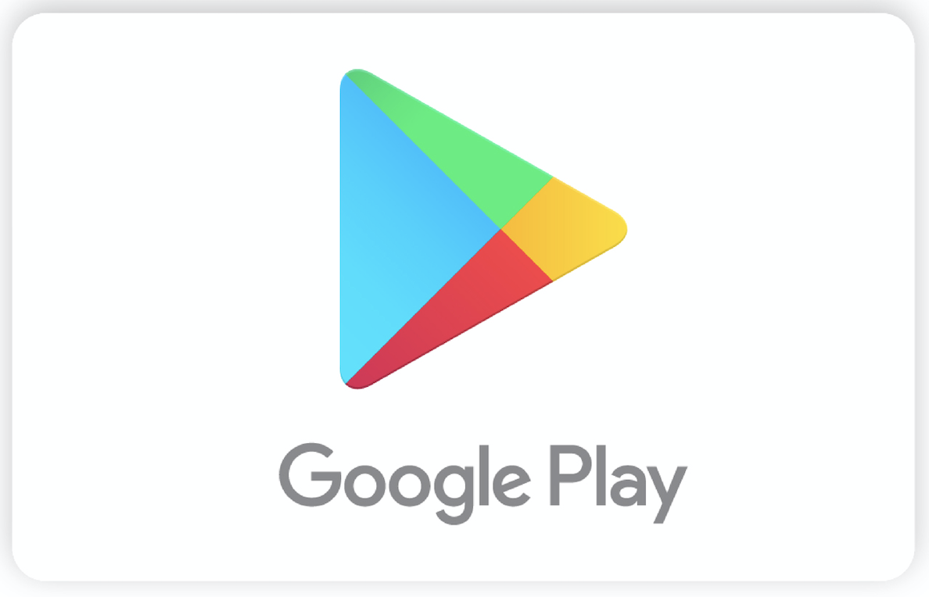

Marketing Description | Power up in over 1M Android apps and games on Google Play, the world's largest mobile gaming platform. Use a Google Play gift card to go further in your favorite games like Clash Royale or Pokemon Go or redeem your card for the latest apps, movies, books, and more. There’s no credit card required, and balances never expire. Treat yourself or give the gift of Play today.
Redemption Instructions  . | To redeem in the Play Store:  1. On your Android phone or tablet, open the Play Store app. Tap the menu icon and select Redeem. On your laptop, go to play.google.com/redeem.  2. Scratch label off of card and enter code.  3. Start shopping! Your gift card value will be added to your Google Play balance.
Terms and Conditions | Use of card subject to additional terms and privacy policy: play.google.com/about/card-terms.html. Valid only for users 13+ years of age and resident of U.S. Redemption requires Google Payments account and internet access. Limits may apply to redemption and use. Not usable for hardware and subscriptions unless specifically noted, see full terms for details. No fees or expiration dates applicable to this card. Card may be used for purchases of eligible items on Google Play only. Any refunded amount will be credited back to your Google Play balance for future use under same terms. Card is not redeemable for cash or other cards; not reloadable or refundable; cannot be combined with other non-Google Play balances in your Google Payments account, resold, exchanged or transferred for value (except as required by law). Once card is purchased, risk of loss and title for card passes to purchaser. Google Payment Corp. and its affiliates disclaim all express or implied warranties as to the Google Play card and Google Play. For assistance or to view your Google Play card balance, visit support.google.com/googleplay/go/cardhelp. To speak to customer care call us at 1-855-466-4438.

